SIMATS ENGINEERING
Department of Computer Science and Engineering

ASSESSMENT TOOL 1 – ANALYTICAL PROBLEM SOLVING

Course Code: | CSA12 | Course Title: | Computer Architecture
CO Assessed: | CO2 – Precision (BL3) | Assessment: | Analytical Problem Solving
Weightage: | 45% | Total Marks: | 100
CO2 Statement: | Apply integer and floating-point arithmetic algorithms including Booth's multiplication, restoring/non-restoring division, and IEEE 754 standard operations to solve fixed-point and floating-point computational problems.
Student Name: |  | Reg. No.:
Section / Batch: |  | Date:
Instructions to Students
- Identify the appropriate arithmetic algorithm or number representation required for the given computational problem.
- Analyse the step-by-step execution of integer and floating-point arithmetic operations using the selected algorithm.
- Apply Booth's multiplication, restoring/non-restoring division, and IEEE 754 standards to obtain accurate results.
- Compute binary multiplication, division, normalization, and floating-point arithmetic using appropriate algorithms.
- Interpret the computed results by evaluating their accuracy, precision, and suitability for the given application.

QUESTIONS
- A digital computer performs signed integer arithmetic using 8-bit 2's complement representation. Consider the numbers −75 and +38. Analyze how the processor performs both addition and subtraction by converting the operands to binary, executing the operations step-by-step, detecting overflow (if any), and interpreting the final results in both binary and decimal forms.
- A high-performance processor employs an 8-bit carry look-ahead adder (CLA) to enhance arithmetic speed. Given two binary operands, analyse how the generate and propagate signals are produced, how carry bits are calculated simultaneously, and compare the execution time and hardware complexity of both adders. Explain why CLA is widely used in modern processors.
- A digital processing unit executes signed multiplication using Booth's algorithm. Multiply +13 and −6, and analyze the algorithm step-by-step by showing the contents of the accumulator, multiplier, multiplicand, and Booth bit after each iteration. Explain the purpose of arithmetic right shifts and discuss how Booth's algorithm reduces the number of addition and subtraction operations.
- A binary arithmetic unit supports both restoring and non-restoring division methods for signed integer operations. Analyze the division of the binary numbers 27 ÷ 5 using each algorithm by showing the intermediate remainder values, quotient formation, and register contents after every iteration. Compare the two methods based on execution steps, computational complexity, and hardware efficiency, and justify which algorithm is more suitable for high-speed processors.
- A floating-point processing unit represents real numbers using the IEEE 754 standard. Analyze the representation of the decimal number −42.375 in both single-precision (32-bit) and double-precision (64-bit) formats by identifying the sign, exponent, and mantissa fields. Further, explain how floating-point addition is performed between −42.375 and +15.125, including exponent alignment, mantissa operations, normalization, rounding, and the impact of precision on the final result.
Code of Conduct
I (Name / Reg No) certify that this submission is my original work and that I have adhered to the guidelines specified for this assessment. I understand that any violation of academic integrity rules will result in disciplinary action.

Signature of the Student:

RUBRICS FOR CALCULATION

Criteria | Weightage | Level 4 – Exemplary (5 Marks) | Level 3 – Proficient (4 Marks) | Level 2 – Developing (2–3 Marks) | Level 1 – Beginning (0–1 Mark)
Problem Understanding | 20% | Clearly interprets problem, identifies all parameters and requirements accurately | Understands problem with minor gaps | Partial understanding; misses key elements | Misinterprets or unable to understand problem
Method Selection | 20% | Selects most appropriate method/formula with strong justification | Selects correct method with minor errors | Inappropriate or partially correct method | Unable to select method
Solution Process | 25% | Logical, systematic steps with correct approach throughout | Mostly correct steps with minor mistakes | Disorganized steps; multiple errors | No clear process
Accuracy of Calculation | 20% | All calculations accurate; correct final answer | Minor calculation errors | Frequent errors; incorrect final answer | No valid calculations
Interpretation of Results | 15% | Clearly interprets results with units and engineering relevance | Basic interpretation with minor omissions | Limited or unclear interpretation | No interpretation

Marks Evaluation:

Q.  No | Problem Understanding (20) |  | Method Selection (20) | Solution Process (25) | Accuracy of Calculation (20) | Interpretation of Results (15) | Total (out of 100)
1 | / 4 |  | / 4 | / 4 | / 4 | / 4
2 | / 4 |  | / 4 | / 4 | / 4 | / 4
3 | / 4 |  | / 4 | / 4 | / 4 | / 4
4 | / 4 |  | / 4 | / 4 | / 4 | / 4
5 | / 4 |  | / 4 | / 4 | / 4 | / 4
 | / 20 |  | / 20 | / 25 | / 20 | / 15 | / 100

Course Coordinator Faculty Incharge

A digital computer performs signed integer arithmetic using 8-bit 2's complement representation. Consider the numbers −75 and +38. Analyze how the processor performs both addition and subtraction by converting the operands to binary, executing the operations step-by-step, detecting overflow (if any), and interpreting the final results in both binary and decimal forms. 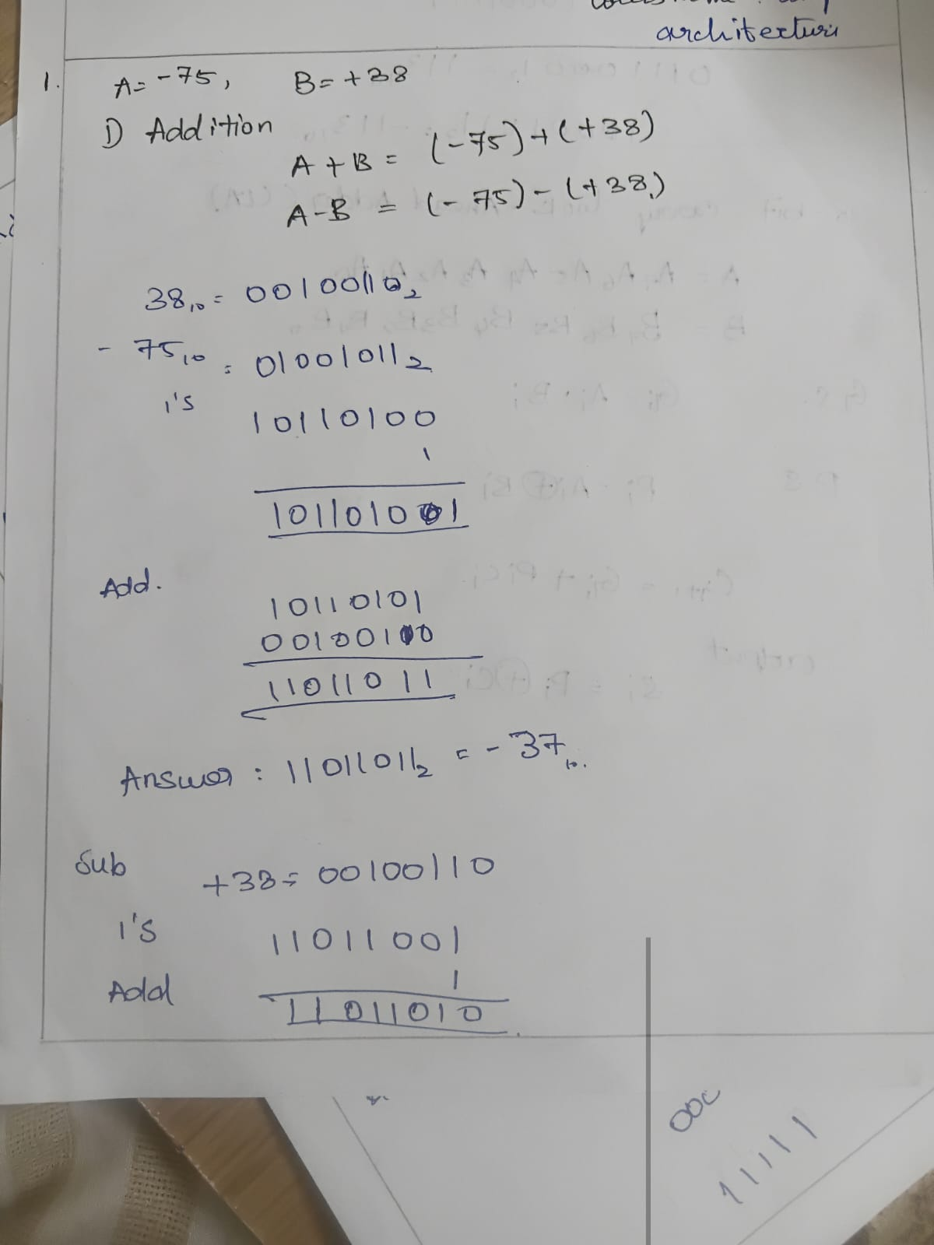

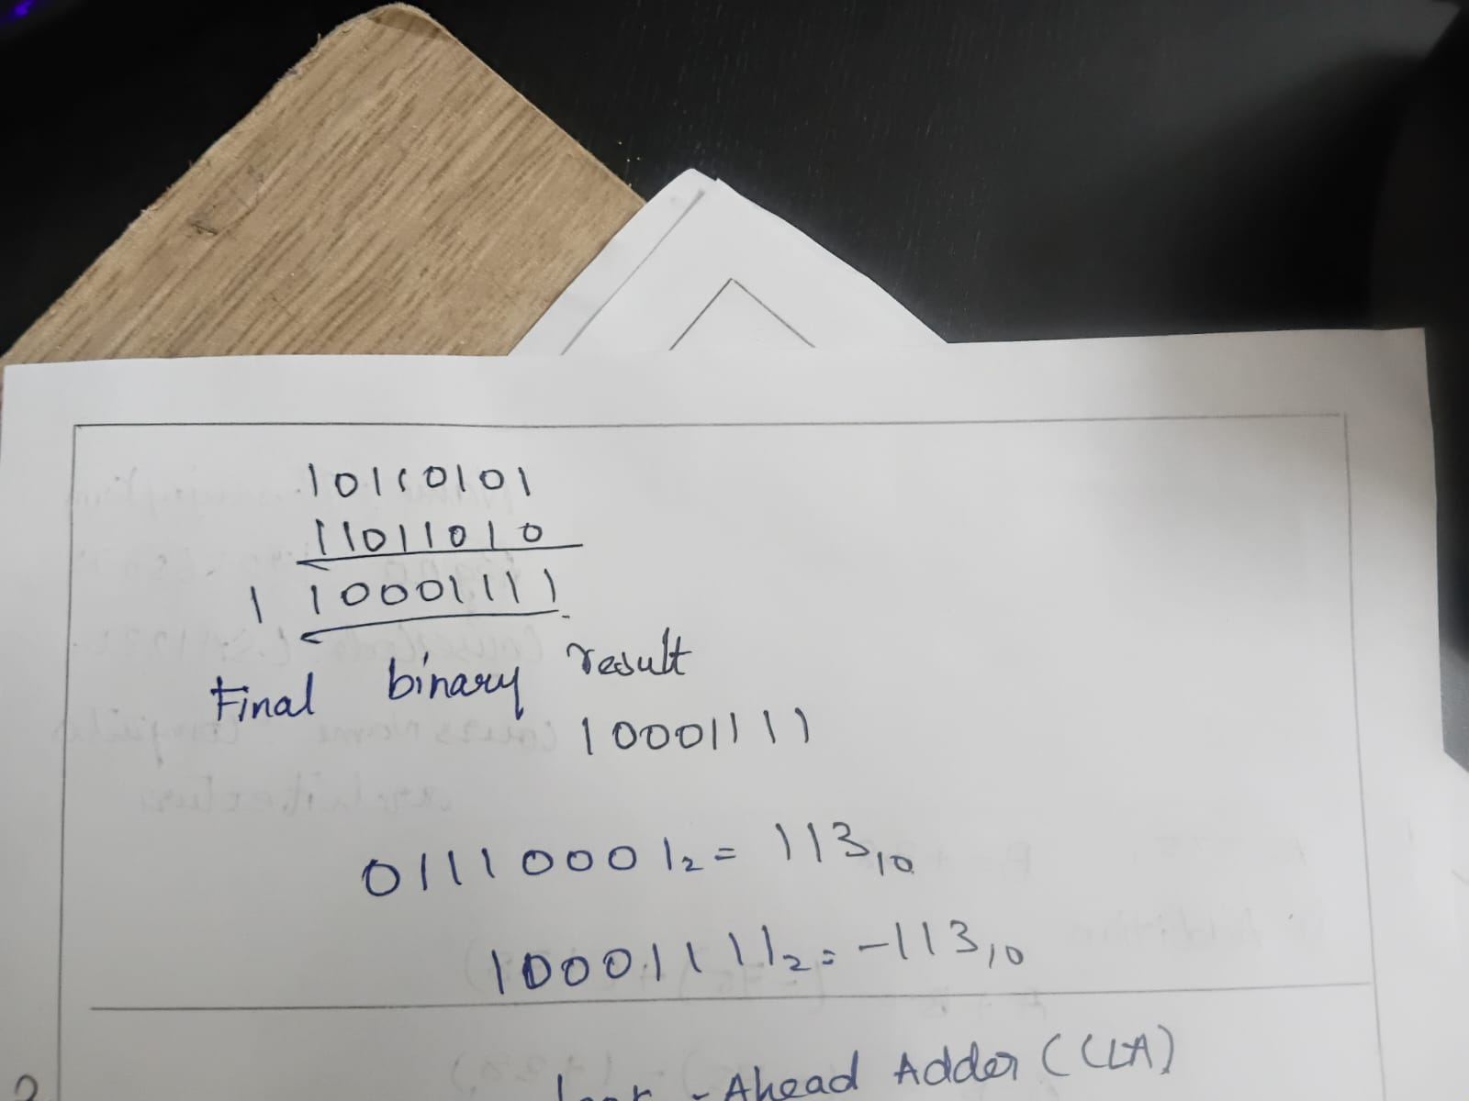

2. Analysis and Implementation
The decimal numbers are first converted into 8-bit binary. The positive number +38 is represented directly in binary as 00100110. To represent −75, the binary form of +75 (01001011) is obtained first, then its 2's complement is calculated by taking the 1's complement and adding 1, resulting in 10110101.
For the addition operation, the processor adds the binary values of −75 and +38. The resulting binary value is 11011011, which represents −37 in decimal. Since one operand is positive and the other is negative, no overflow occurs.
For the subtraction operation, the processor performs subtraction by adding the 2's complement of +38 to −75. The 2's complement of 00100110 is 11011010, which represents −38. Adding this value to −75 produces the binary result 10001111, which is equal to −113 in decimal. The result lies within the valid 8-bit signed range (−128 to +127), so no overflow occurs.

3. Final Result
Operation | Binary Result | Decimal Result | Overflow
−75 + 38 | 11011011 | −37 | No
−75 − 38 | 10001111 | −113 | No
Conclusion:
The processor correctly performs signed addition and subtraction using the 8-bit 2's complement representation. The final addition result is −37, the final subtraction result is −113, and no overflow is detected because both results are within the allowable 8-bit signed integer range.
- A high-performance processor employs an 8-bit carry look-ahead adder (CLA) to enhance arithmetic speed. Given two binary operands, analyze how the generate and propagate signals are produced, how carry bits are calculated simultaneously, and compare the execution time and hardware complexity of both adders. Explain why CLA is widely used in modern processors
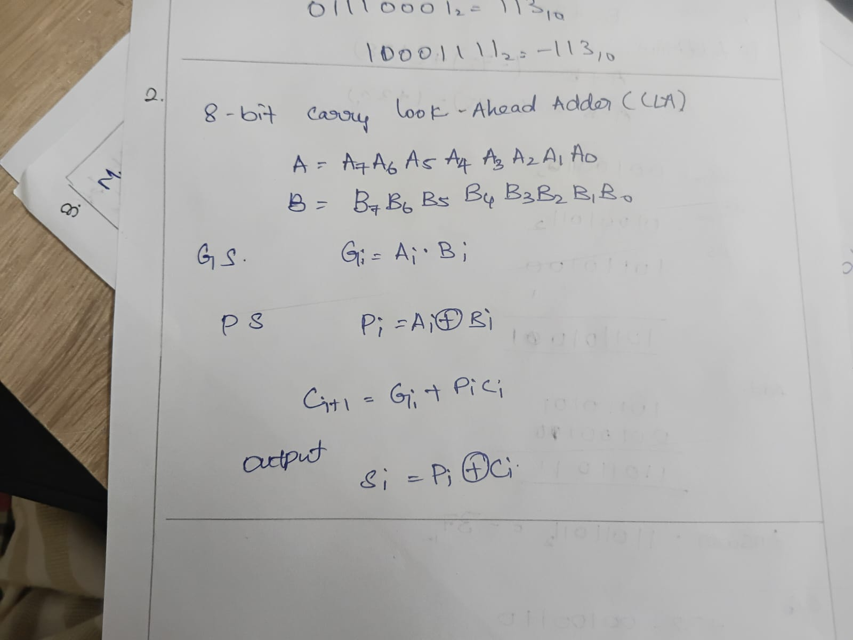`
2. Analysis and Implementation
The Carry Look-Ahead Adder (CLA) is designed to overcome the delay caused by the Ripple Carry Adder. In an RCA, each carry bit must wait for the previous carry to be generated before the next addition can proceed. This increases the overall execution time, especially for large binary numbers.
In a CLA, two signals are generated for every bit position:
- Generate (G): Indicates that a carry is generated at that bit regardless of the input carry.
- Propagate (P): Indicates that an incoming carry will be propagated to the next bit.
Using these Generate and Propagate signals, the processor computes all carry bits simultaneously through carry look-ahead logic instead of waiting for carries to ripple through each stage. This significantly reduces propagation delay and increases the speed of arithmetic operations.
Compared with the Ripple Carry Adder, the CLA requires more hardware because it contains additional logic gates for carry generation. However, the increased hardware complexity is justified by its much faster performance. Therefore, Carry Look-Ahead Adders are commonly used in modern processors, digital signal processors, and high-performance computing systems where fast arithmetic operations are essential.
3. Final Result
Feature | Ripple Carry Adder (RCA) | Carry Look-Ahead Adder (CLA)
Carry Generation | Sequential (one by one) | Simultaneous (all at once)
Speed | Slower | Faster
Propagation Delay | High | Very Low
Hardware Complexity | Simple | More Complex
Number of Logic Gates | Fewer | More
Processor Usage | Small circuits | Modern processors and CPUs
Conclusion
The Carry Look-Ahead Adder (CLA) improves arithmetic performance by calculating carry bits simultaneously using Generate and Propagate signals. Although it requires more hardware than the Ripple Carry Adder, it provides much faster execution with lower propagation delay. This makes the CLA the preferred choice for modern high-speed processors and digital systems.

- A digital processing unit executes signed multiplication using Booth's algorithm. Multiply +13 and −6, and analyze the algorithm step-by-step by showing the contents of the accumulator, multiplier, multiplicand, and Booth bit after each iteration. Explain the purpose of arithmetic right shifts and discuss how Booth's algorithm reduces the number of addition and subtraction operations.
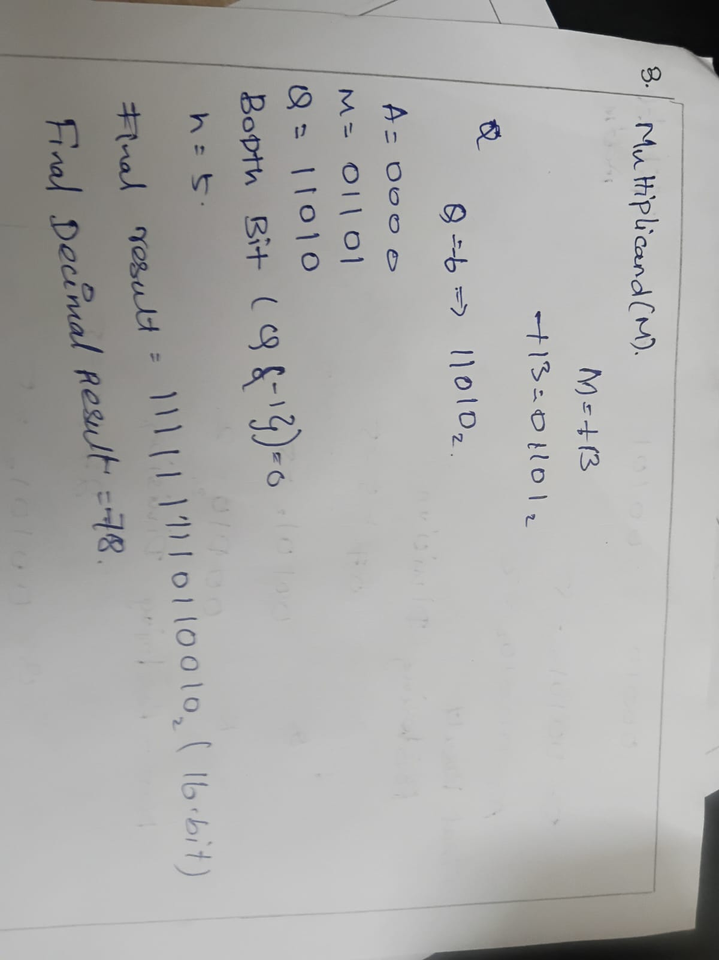

2. Analysis and Implementation
Booth's Algorithm is an efficient method for multiplying signed binary numbers represented in 2's complement form. It is widely used in processors because it reduces the number of arithmetic operations required during multiplication.
Initially, the multiplicand (M), multiplier (Q), accumulator (A), and Booth bit (Q-1) are loaded into their respective registers. During each iteration, the processor examines the last bit of the multiplier (Q₀) and the Booth bit (Q-1).
If Q₀Q-1 = 01, the multiplicand is added to the accumulator.
If Q₀Q-1 = 10, the multiplicand is subtracted from the accumulator.
If Q₀Q-1 = 00 or 11, no arithmetic operation is performed.
After the required addition or subtraction, the combined contents of A, Q, and Q-1 undergo an arithmetic right shift. This shift preserves the sign bit while moving all bits one position to the right. The process is repeated for the number of bits in the multiplier until all iterations are completed.
Booth's Algorithm is particularly efficient because it treats consecutive 1's in the multiplier as a single operation instead of performing repeated additions. This reduces the total number of arithmetic operations and improves processor performance.
3. Final Result
Parameter | Value
Multiplicand (M) | +13
Multiplier (Q) | −6
Multiplication Performed | (+13) × (−6)
Final Decimal Result | −78
Final Binary Result (16-bit) | 1111111110110010₂
Conclusion
Booth's Algorithm successfully multiplies +13 and −6 to produce the final result −78. The algorithm uses addition, subtraction, and arithmetic right shifts to perform signed multiplication efficiently. By reducing unnecessary addition and subtraction operations, Booth's Algorithm provides faster execution and is widely used in modern computer processors for signed binary multiplication.

- A binary arithmetic unit supports both restoring and non-restoring division methods for signed integer operations. Analyze the division of the binary numbers 27 ÷ 5 using each algorithm by showing the intermediate remainder values, quotient formation, and register contents after every iteration. Compare the two methods based on execution steps, computational complexity, and hardware efficiency, and justify which algorithm is more suitable for high-speed processors.
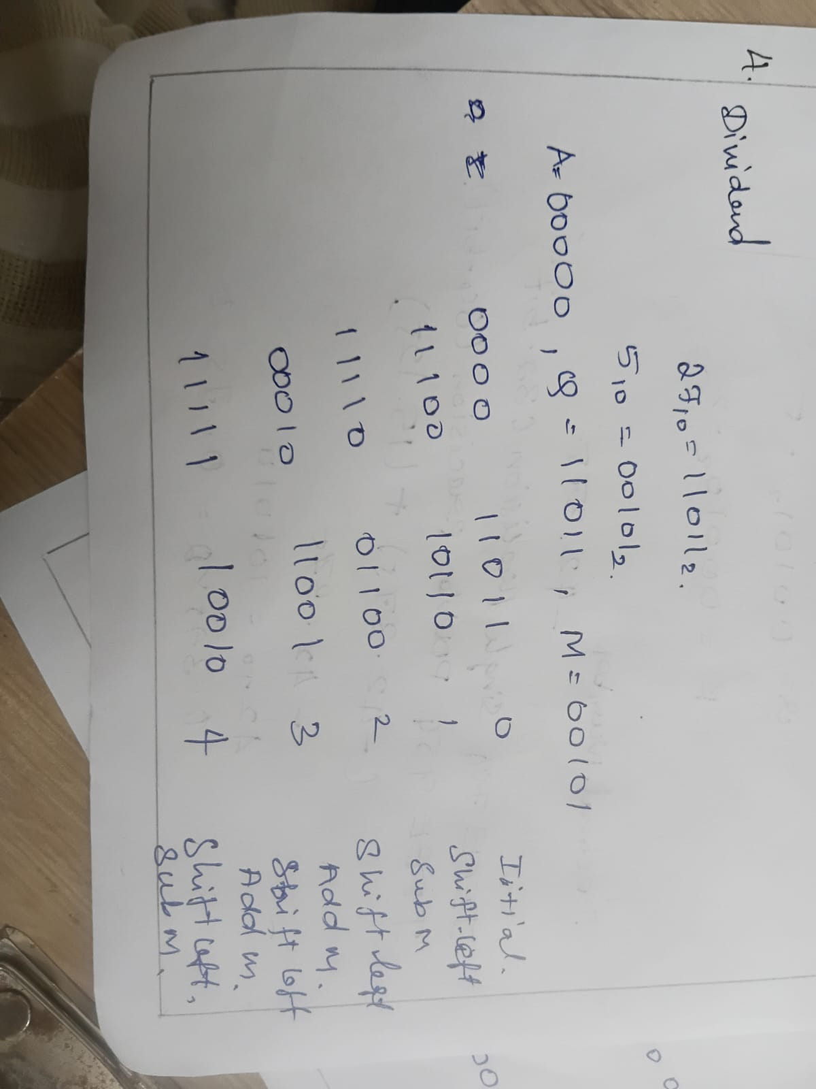
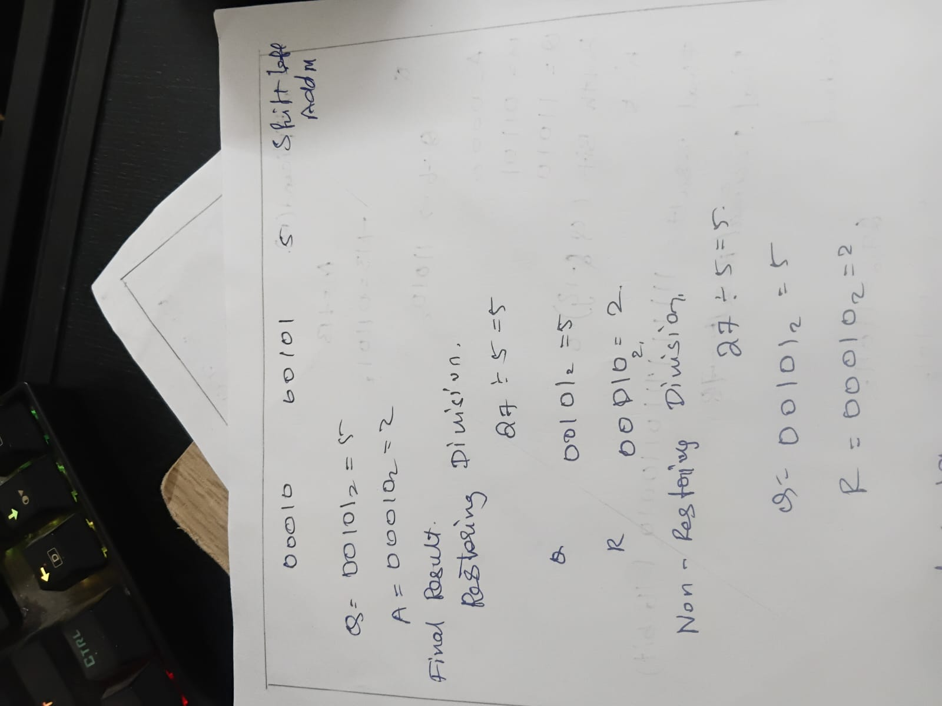
2. Analysis and Implementation
The processor performs binary division using two different algorithms: Restoring Division and Non-Restoring Division.
In the Restoring Division Algorithm, the dividend (27) and divisor (5) are first converted into binary form. During each iteration, the accumulator and quotient registers are shifted to the left, and the divisor is subtracted from the accumulator. If the remainder becomes negative, the original value is restored by adding the divisor back, and the quotient bit is set to 0. If the remainder is positive, the quotient bit is set to 1. This process continues until all bits have been processed. Although the restoring method is simple to understand and implement, it requires an additional restoration step whenever the remainder becomes negative, increasing the execution time.
In the Non-Restoring Division Algorithm, the processor also begins by loading the dividend and divisor into registers. After each left shift, the processor either subtracts or adds the divisor depending on whether the previous remainder is positive or negative. Since the remainder is not immediately restored after a negative result, the algorithm eliminates unnecessary restoration operations. At the end of the division process, if the final remainder is negative, one final correction is performed by adding the divisor. This reduces the number of arithmetic operations and improves the overall execution speed.
When comparing the two methods, the Restoring Division Algorithm is easier to implement but requires more arithmetic operations because of the restoration process. The Non-Restoring Division Algorithm performs fewer operations, has lower execution time, and is therefore more efficient for modern high-speed processors.
3. Final Result
Parameter | Value
Dividend | 27
Divisor | 5
Quotient | 5
Remainder | 2
Comparison of Division Algorithms
Feature | Restoring Division | Non-Restoring Division
Restoration Step | Required | Not Required
Number of Operations | More | Fewer
Execution Speed | Slower | Faster
Hardware Efficiency | Moderate | High
Complexity | Simple | Slightly Complex
Suitable for High-Speed Processors | No | Yes
Conclusion
Both Restoring Division and Non-Restoring Division correctly compute 27 ÷ 5, producing a quotient of 5 and a remainder of 2. The Non-Restoring Division Algorithm is more efficient because it avoids repeated restoration steps, reducing execution time and hardware operations. For this reason, it is widely preferred in modern high-speed processors and digital arithmetic units.
- A floating-point processing unit represents real numbers using the IEEE 754 standard. Analyze the representation of the decimal number −42.375 in both single-precision (32-bit) and double-precision (64-bit) formats by identifying the sign, exponent, and mantissa fields. Further, explain how floating-point addition is performed between −42.375 and +15.125, including exponent alignment, mantissa operations, normalization, rounding, and the impact of precision on the final result. 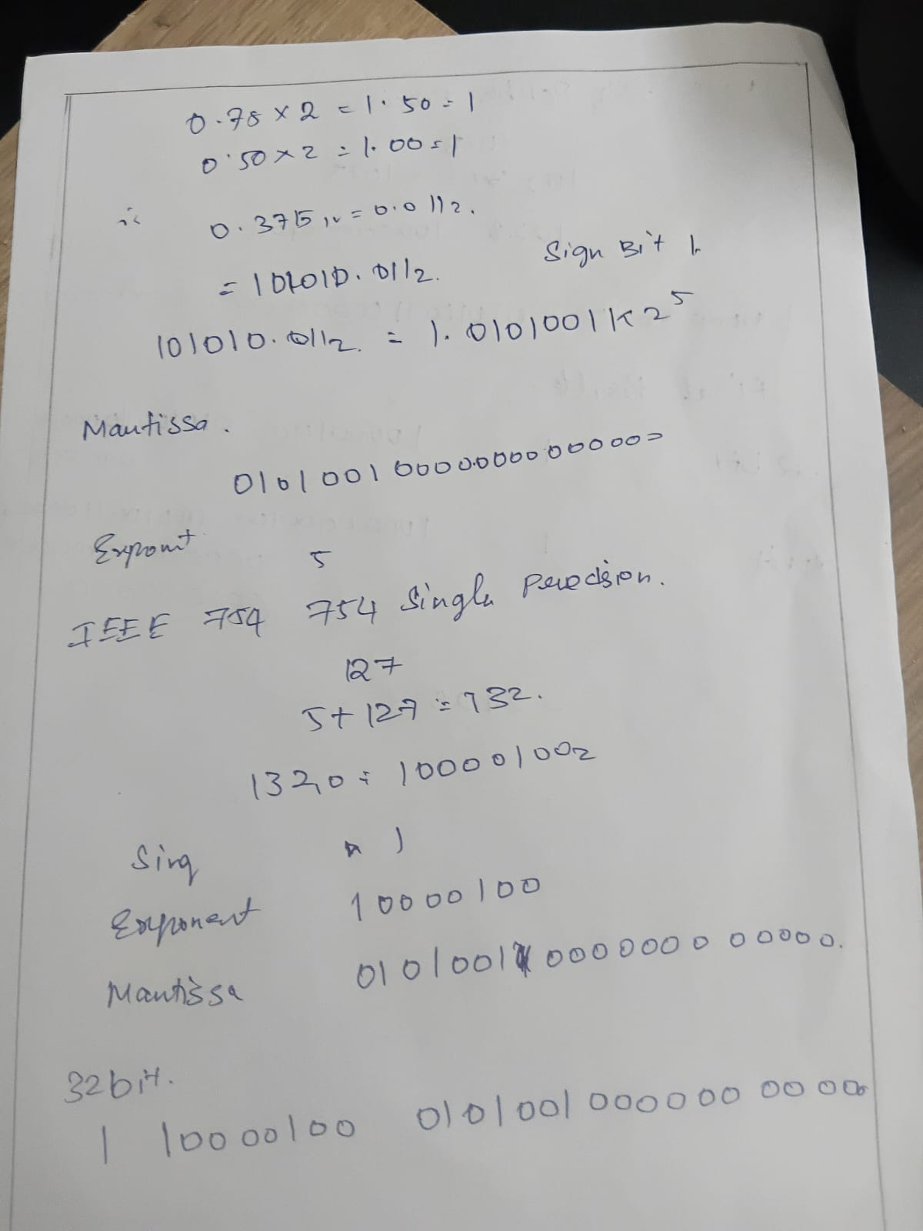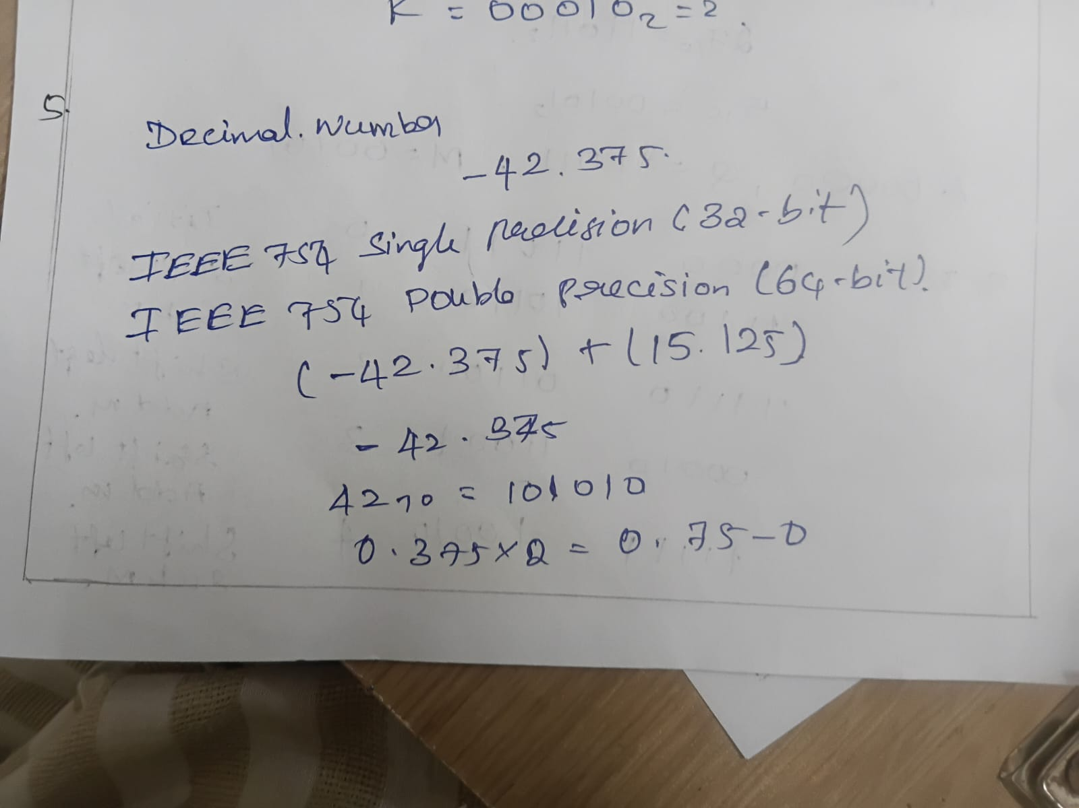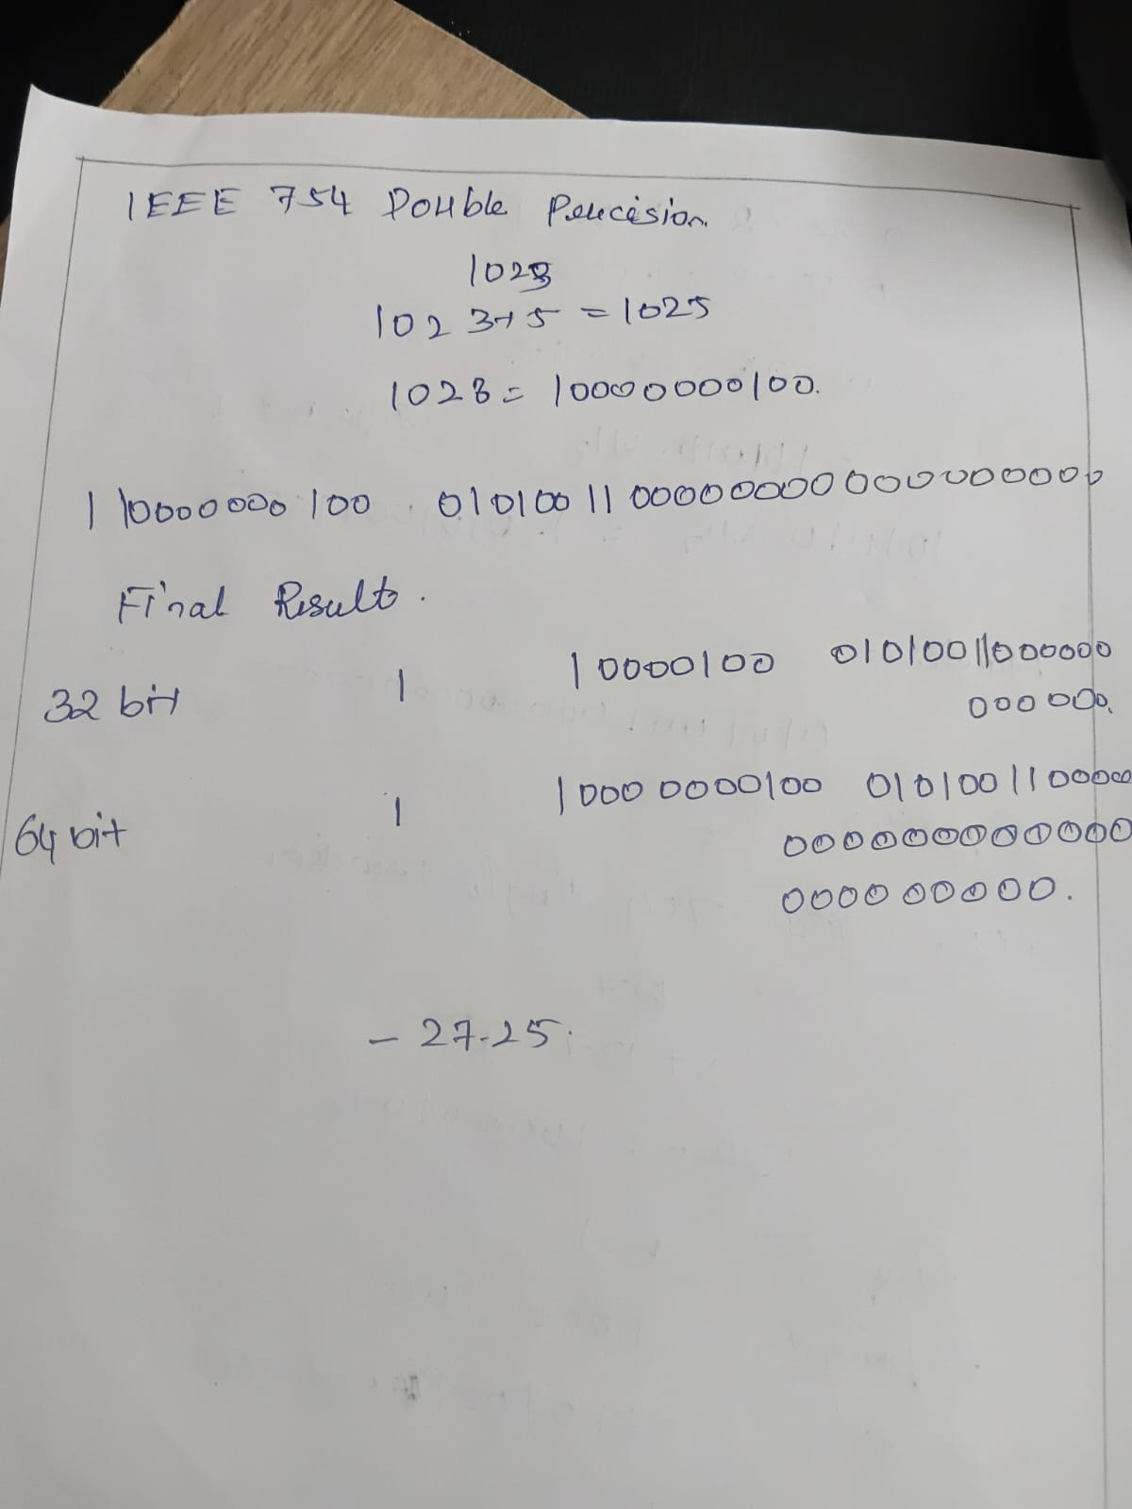
2. Analysis and Implementation
The IEEE 754 standard is the most widely used format for representing floating-point numbers in computer systems. It divides every floating-point number into three fields: the sign bit, exponent, and mantissa (fraction).
First, the decimal number −42.375 is converted into binary. Since the number is negative, the sign bit is set to 1. The binary value is then normalized into the form 1.xxxxx × 2ⁿ. The exponent is calculated by adding the bias value (127 for single precision and 1023 for double precision), and the remaining fractional bits are stored in the mantissa field. The same normalized value is represented in both 32-bit and 64-bit IEEE 754 formats, with the double-precision format providing a larger exponent range and a more accurate mantissa.
For floating-point addition, the processor first compares the exponents of −42.375 and +15.125. The number with the smaller exponent is shifted to align both exponents. After alignment, the mantissas are added or subtracted according to the sign of the operands. The resulting value is then normalized so that the leading digit is 1, and rounding is applied if necessary to fit the available mantissa bits. Finally, the processor stores the result in IEEE 754 format.
The final arithmetic result is −27.25, which is represented accurately because both numbers can be expressed exactly in binary floating-point format.

3. Final Result
IEEE 754 Representation of −42.375
Format | Sign Bit | Exponent | Mantissa
Single Precision (32-bit) | 1 | 10000100 | 01010011000000000000000
Double Precision (64-bit) | 1 | 10000000100 | 0101001100000000000000000000000000000000000000000000
Floating-Point Addition
Operation | Result
−42.375 + 15.125 | −27.25
Conclusion
The IEEE 754 standard represents floating-point numbers using sign, exponent, and mantissa fields, ensuring consistent arithmetic operations across computer systems. The decimal number −42.375 is successfully represented in both single-precision and double-precision formats. After exponent alignment, mantissa operation, normalization, and rounding, the floating-point addition of −42.375 and +15.125 produces the correct result of −27.25. The 64-bit double-precision format offers greater accuracy and precision than the 32-bit single-precision format because it provides more bits for the exponent and mantiss.

